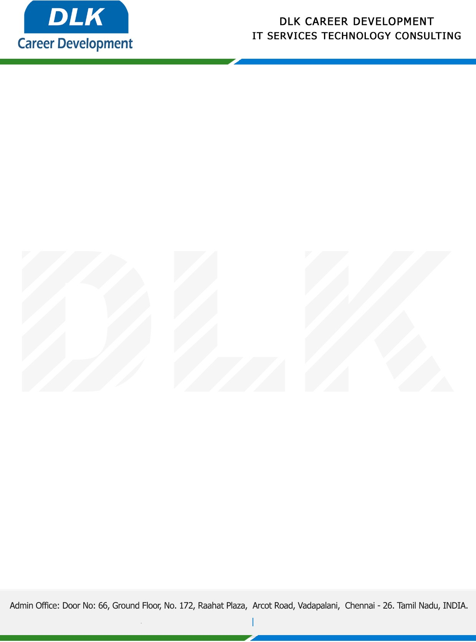

**Date: 18/April /2023**

**SUB: PROJECT COMPLETION CERTIFICATE**

This is to certify that **BCA-Computer Application,** final year students of **SIVET College, Gowrivakkam, Chennai** has Successfully Completed the Project Work under the domain of “**Python”** in our organization during the Period **(1st December 2022 to 28th February 2023)**

**Team Members:**

1. MR VENUGOPAL S (212000110)
2. MR SHANMUGA PRIYAN M (212000101)

**Topic:** Employee Promotion analysis Using Machine learning

We appreciate your interest in **DLK CAREER DEVELOPMENT**

**“Best Wishes for Your Future Endeavors “**

